Hydroxymethylated dihydrocoumarins from γ-irradiated esculin with potent α-glucosidase inhibitory effects
Gyeong Han Jeong^{‡1}, Hanui Lee^{‡1}, So-Yeun Woo¹, Byung Yeoup Chung¹, Seung Ae Kim², Tae Hoon Kim*² and Hyung-Woo Bai^{*1,3}

Address: ¹Research Division for Biotechnology, Advanced Radiation Technology Institute (ARTI), Korea Atomic Energy Research Institute (KAERI), Jeongeup 56212, Republic of Korea, ²Department of Food Science and Biotechnology, Daegu University, Gyeongsan, Republic of Korea, and ³Department of Radiation Science, University of Science and Technology (UST), Daejeon 34113, Republic of Korea.

Email: Tae Hoon Kim* – skyey7@daegu.ac.kr; Hyung-Woo Bai* – hbai@kaeri.re.kr
* Corresponding author
‡ Equal contributors

Contents

Figure S1. HPLC chromatograms of the isolated compounds 2 and 3.
Figure S2. ¹H NMR spectrum of compound 2 in CD₃OD.
Figure S3. ¹³C NMR spectrum of compound 2 in CD₃OD.
Figure S4. HSQC spectrum of compound 2 in CD₃OD.
Figure S5. HMBC spectrum of compound 2 in CD₃OD.
Figure S6. ¹H-¹H COSY spectrum of compound 2 in CD₃OD
Figure S7. NOESY spectrum of compound 2 in CD₃OD.
Figure S8. HRESIMS spectrum of compound 2.
Figure S9. ¹H NMR spectrum of compound 3 in CD₃OD.
Figure S10. ¹³C NMR spectrum of compound 3 in CD₃OD.
Figure S11. HSQC spectrum of compound 3 in CD₃OD.
Figure S12. HMBC spectrum of compound 3 in CD₃OD.
Figure S13. ¹H-¹H COSY spectrum of compound 3 in CD₃OD.
Figure S14. NOESY spectrum of compound 3 in CD₃OD.
Figure S15. HRESIMS spectrum of compound 3.
Figure S16. Determination of sugar configurations of 2 and 3 using revered-phase HPLC.
Table S1. Inhibitory activities of irradiated esculin mixtures against α-glucosidase.

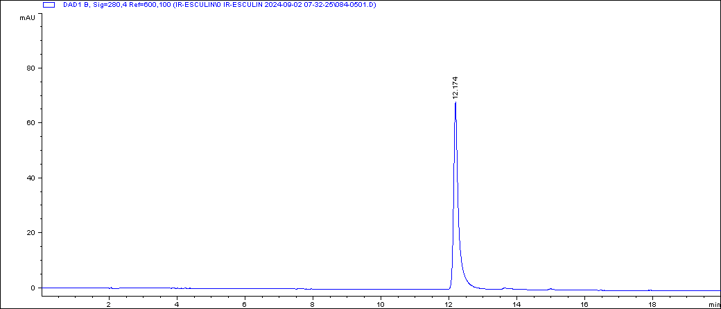
Esculin (1)
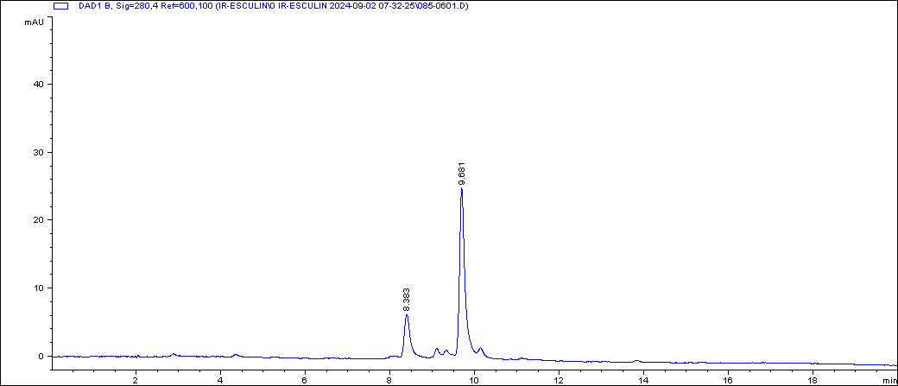
Irradiated esculin (30 kGy)
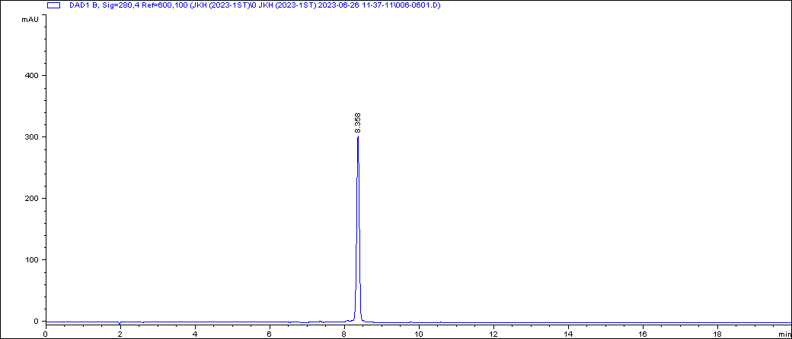
Compound 2
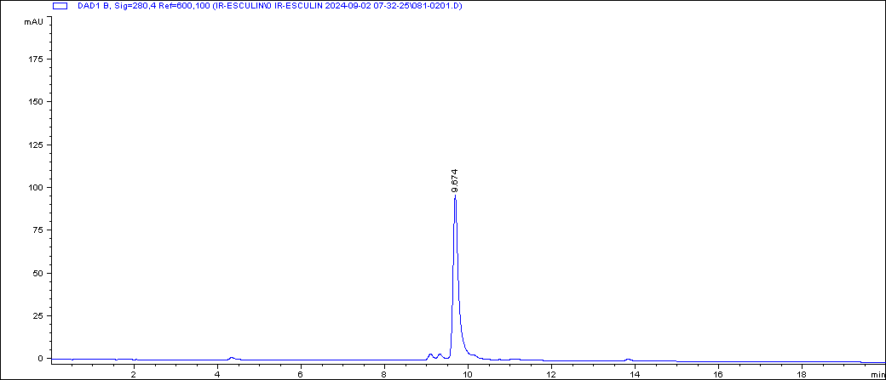
Compound 3
Figure S1. HPLC chromatograms of the isolated compounds 2 and 3.
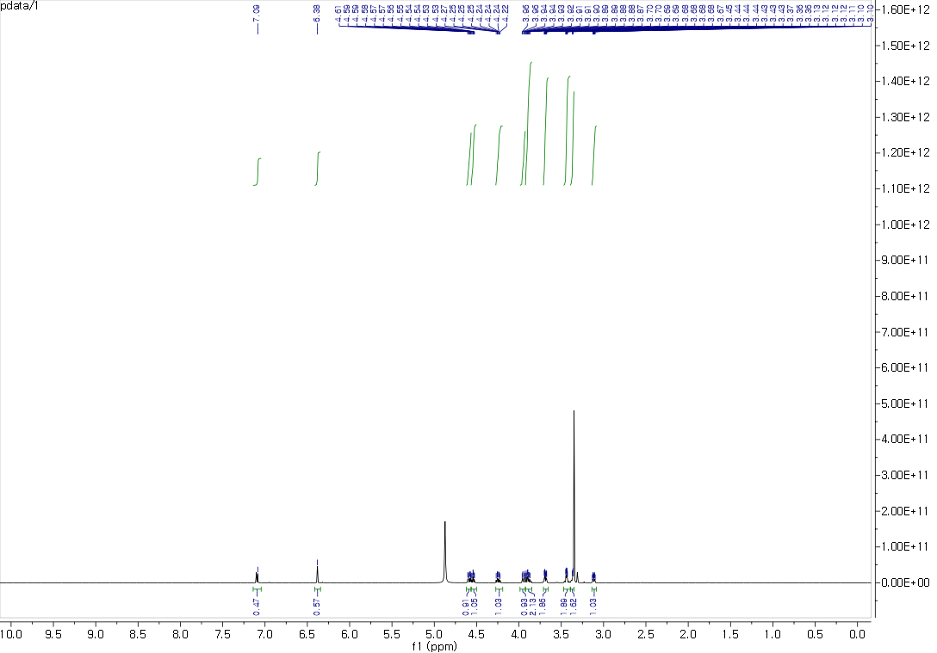
Figure S2. ¹H NMR spectrum of compound 2 in CD₃OD.

Figure S3. ¹³C NMR spectrum of compound 2 in CD₃OD.

Figure S4. HSQC spectrum of compound 2 in CD₃OD.

Figure S5. HMBC spectrum of compound 2 in CD₃OD.

Figure S6. ¹H-¹H COSY spectrum of compound 2 in CD₃OD

Figure S7. NOESY spectrum of compound 2 in CD₃OD.

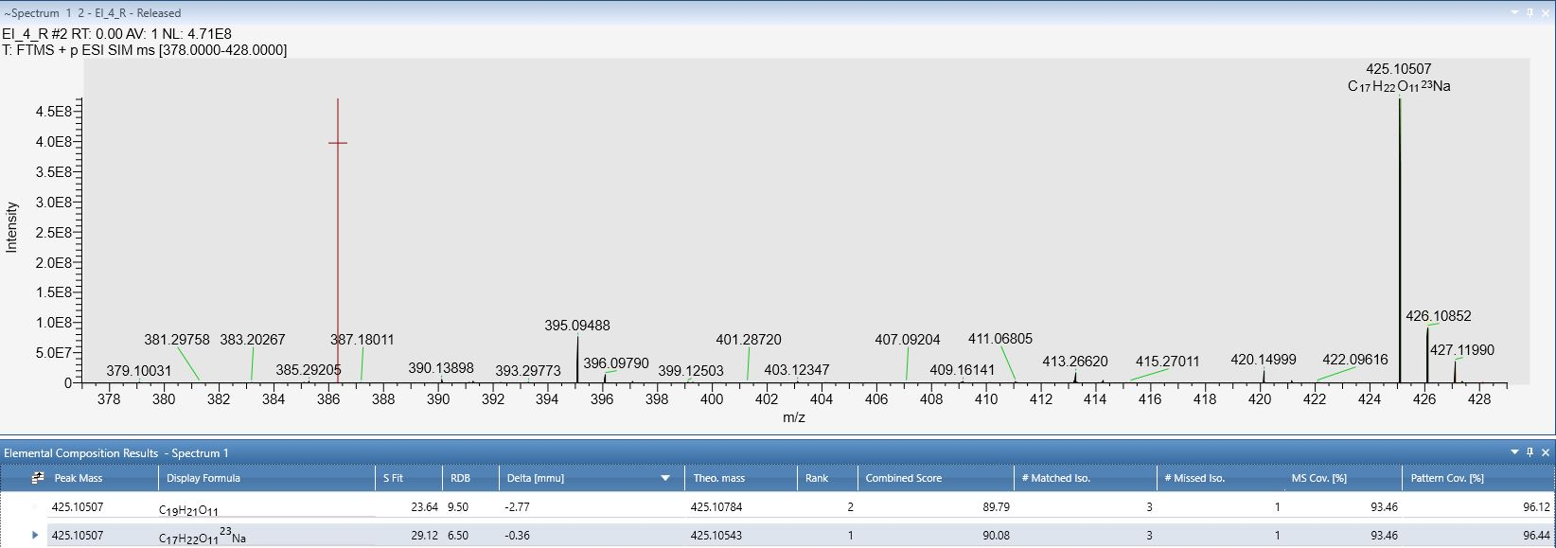
Figure S8. HRESIMS spectrum of compound 2.

Figure S9. ¹H NMR spectrum of compound 3 in CD₃OD.

Figure S10. ¹³C NMR spectrum of compound 3 in CD₃OD.

Figure S11. HSQC spectrum of compound 3 in CD₃OD.

Figure S12. HMBC spectrum of compound 3 in CD₃OD.

Figure S13. ¹H-¹H COSY spectrum of compound 3 in CD₃OD.

Figure S14. NOESY spectrum of compound 3 in CD₃OD.

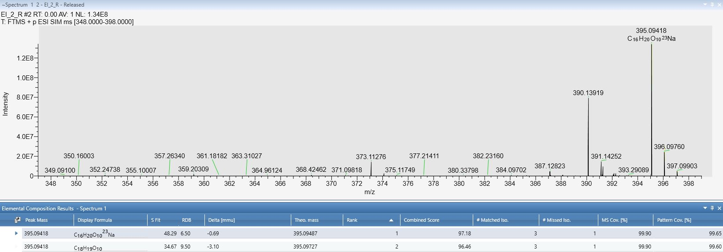
Figure S15. HRESIMS spectrum of compound 3.

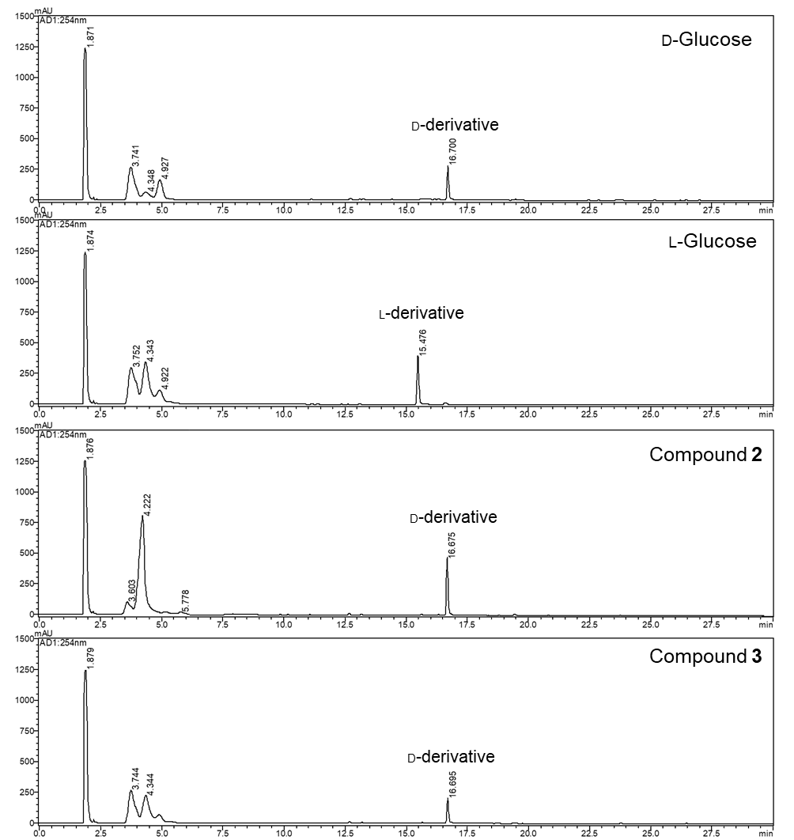
Figure S16. Determination of sugar configurations of 2 and 3 using revered-phase HPLC.

Table S1. Inhibitory activities of irradiated esculin mixtures against α-glucosidase.
Samples | IC₅₀ values (μg/mL)
Esculin | 50.2 ± 1.7
IR-esculin (5 kGy) | 48.0 ± 0.8
IR-esculin (10 kGy) | 40.8 ± 0.9
IR-esculin (20 kGy) | 32.1 ± 0.5
IR-esculin (30 kGy) | 22.9 ± 0.2

