Supporting Information

Figure S1. The high resolution mass spectra of PI-Cz

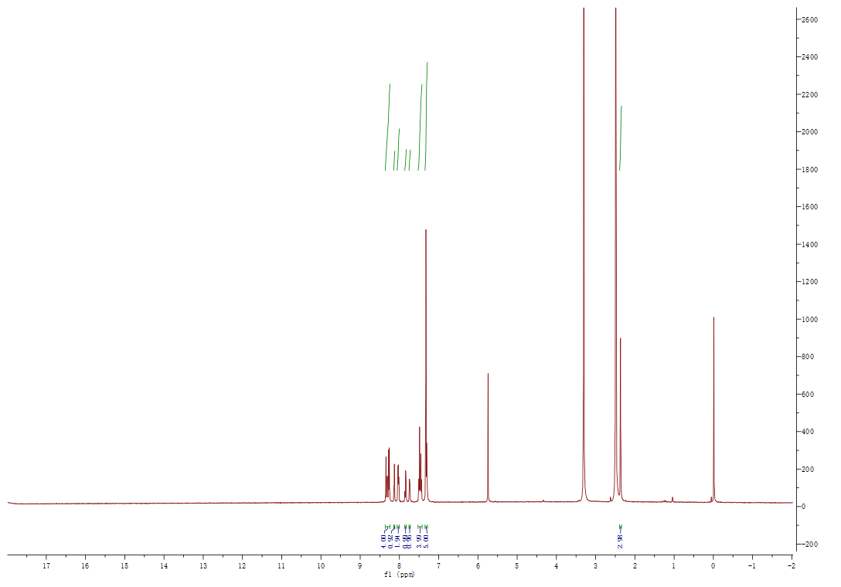
Figure S2. The ¹H NMR spectrum of PI-Cz in DMSO-d₆.

Table S1. Crystal data and structure refinement forPI-Cz
Compound | PI-Cz
Empirical formula | C₃₃H₂₂N₂O₂
Formula weight | 478.52
Temperature/K | 220.00(10)
Crystal system | monoclinic
Space group | P2₁/c
a/Å | 8.6894(2)
b/Å | 35.8672(5)
c/Å | 8.10020(10)
α/° | 90
β/° | 107.351(2)
γ/° | 90
Volume/Å³ | 2409.67(8)
Z | 4
ρ_{calc}g/cm³ | 1.319
μ/mm⁻¹ | 0.653
F(000) | 1000.0
Crystal size/mm³ | 0.23 × 0.15 × 0.04
Radiation | CuKα (λ = 1.54184)
2Θ range for data collection/° | 9.864 to 146.646
Index ranges | -10 ≤ h ≤ 9, -43 ≤ k ≤ 40, -9 ≤ l ≤ 6
Reflections collected | 7798
Independent reflections | 4617 [R_{int} = 0.0301, R_{sigma} = 0.0400]
Data/restraints/parameters | 4617/0/335
Goodness-of-fit on F² | 0.997
Final R indexes [I>=2σ (I)] | R₁ = 0.0489, wR₂ = 0.1351
Final R indexes [all data] | R₁ = 0.0544, wR₂ = 0.1427

